**Virtual Circuits and Datagram Network**

Computer networks that provide connection-oriented service are called Virtual Circuits while those providing connection-less services are called as Datagram networks. For prior knowledge, the Internet which we use is actually based on Datagram network (connection-less) at the network level as all packets from a source to a destination do not follow the same path.  
Let us see what are the highlighting differences between these two hot debated topics here:

**Virtual Circuits:**

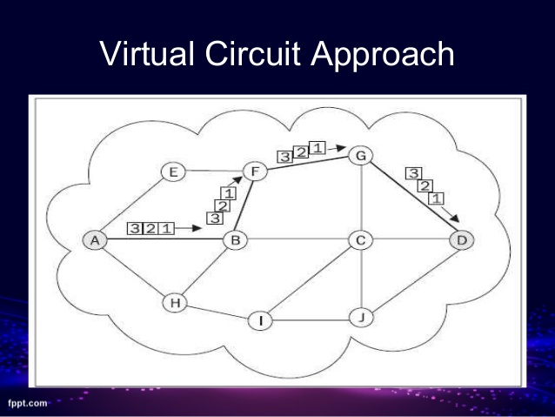

1. It is connection-oriented, meaning that there is a reservation of resources like buffers, CPU, bandwidth, etc. for the time in which the newly setup VC is going to be used by a data transfer session.
2. The first sent packet reserves resources at each server along the path. Subsequent packets will follow the same path as the first sent packet for the connection time.
3. Since all the packets are going to follow the same path, a global header is required. Only the first packet of the connection requires a global header, the remaining packets generally don’t require global headers.
4. Since all packets follow a specific path, packets are received in-order at the destination.
5. Virtual Circuit Switching ensures that all packets successfully reach the Destination. No packet will be discarded due to unavailability of resources.
6. From the above points, it can be concluded that Virtual Circuits are a highly reliable method of data transfer.
7. The issue with virtual circuits is that each time a new connection is set up, resources and extra information have to be reserved at every router along the path, which becomes problematic if many clients are trying to reserve a routers resources simultaneously.
8. It is used by the ATM (Asynchronous Transfer Mode) Network, specifically for Telephone calls.

**Datagram Networks :**

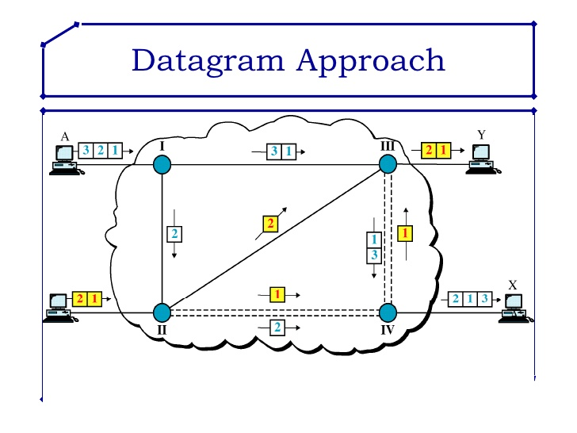

1. It is a connection-less service. There is no need for reservation of resources as there is no dedicated path for a connection session.
2. All packets are free to use any available path. As a result intermediate routers calculate routes on the go due to dynamically changing routing tables on routers.
3. Since every packet is free to choose any path, all packets must be associated with a header with proper information about the source and the upper layer data.
4. The connection-less property makes data packets reach the destination in any order, which means that they can potentially be received out of order at the receivers end.
5. Datagram networks are not as reliable as Virtual Circuits.
6. The major drawback of Datagram Packet switching is that a packet can only be forwarded if resources such as the buffer,CPU and bandwidth are available. Otherwise, the packet will be discarded.
7. But it is always easy and cost-efficient to implement datagram networks as there is no extra headache of reserving resources and making a dedicated each time an application has to communicate.
8. Its is generally used by the IP network, which is used for Data services like Internet.

## **X.25**

X.25 is a protocol suite defined by ITU-T for packet switched communications over WAN (Wide Area Network). It was originally designed for use in the 1970s and became very popular in 1980s. Presently, it is used for networks for ATMs and credit card verification. It allows multiple logical channels to use the same physical line. It also permits data exchange between terminals with different communication speeds.

**X.25 has three protocol layers**

* **Physical Layer:** It lays out the physical, electrical and functional characteristics that interface between the computer terminal and the link to the packet switched node. X.21 physical implementer is commonly used for the linking.
* **Data Link Layer:** It comprises the link access procedures for exchanging data over the link. Here, control information for transmission over the link is attached to the packets from the packet layer to form the LAPB frame (Link Access Procedure Balanced). This service ensures a bit-oriented, error-free, and ordered delivery of frames.
* **Packet Layer:** This layer defines the format of data packets and the procedures for control and transmission of the data packets. It provides external virtual circuit service. Virtual circuits may be of two types: virtual call and permanent virtual circuit. The virtual call is established dynamically when needed through call set up procedure, and the circuit is relinquished through call clearing procedure. Permanent virtual circuit, on the other hand, is fixed and network assigned.

## Equipment used

* **X.21** implementer
* **DTE** − Data Terminal Equipmen
* **DCTE** − Data Circuit Terminating Equipment

## Frame Relay

Frame Relay is a packet switched communication service from LANs (Local Area Network) to backbone networks and WANs. It operates at two layers: physical layer and data link layer. It supports all standard physical layer protocols. It is mostly implemented at the data link layer.

Frame Relay uses virtual circuits to connect a single router to multiple remote sites. In most cases, permanent virtual circuits are used, i.e. a fixed network-assigned circuit is used through which the user sees a continuous uninterrupted line. However, switched virtual circuits may also be used.

Frame relay is a fast packet technology based on X.25. Data is transmitted by encapsulating them in multiple sized frames. The protocol does not attempt to correct errors and so it is faster. Error correction is handled by the endpoints, which are responsible for retransmission of dropped frames

## Frame Relay Devices are

* **DTE** − Data Terminal Equipment
* **DCTE:** − Data Circuit Terminating Equipment